Lab 8: Hydra

* Show a screenshot showing that you found the password via Hydra.

Used the gui because I’m a noob

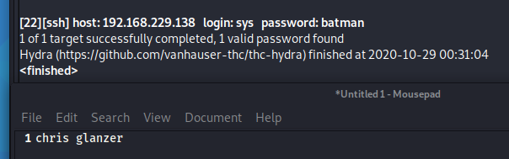

* Show a screenshot showing that you telneted into Metasploitable 2.

